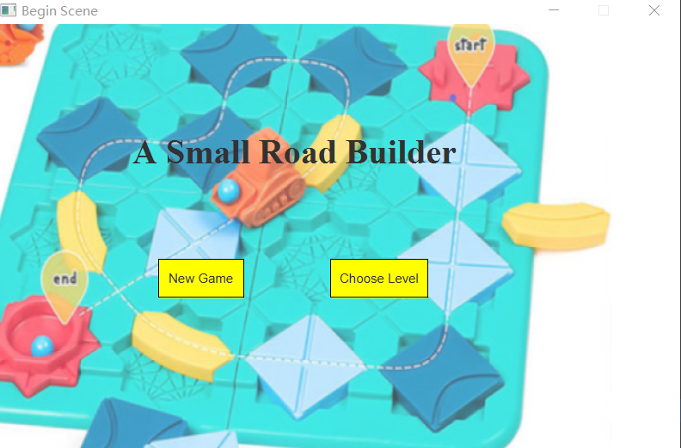

A puzzle game start screen, including a new game option and select the difficulty of the level option, new game option will default to start the first level.

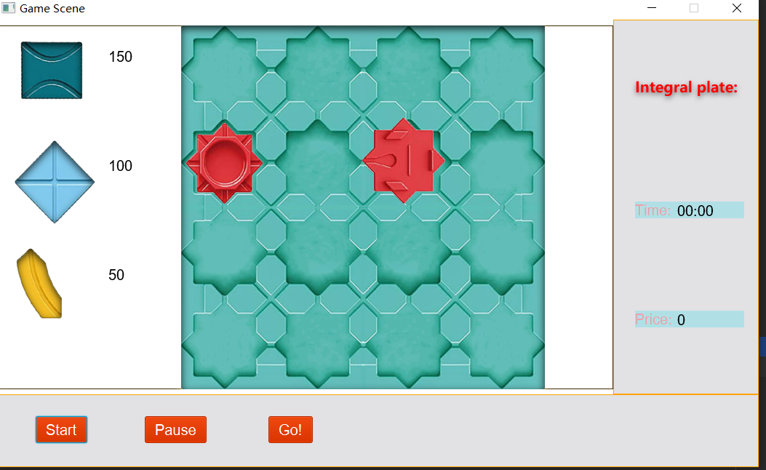

This is the page of the first level, where the player clicks to create a new game and enters. The player selects different types of puzzle pieces on the left side. Different puzzle pieces have different costs, and the less the cost, the higher the score.

PRESS A to rotate the piece

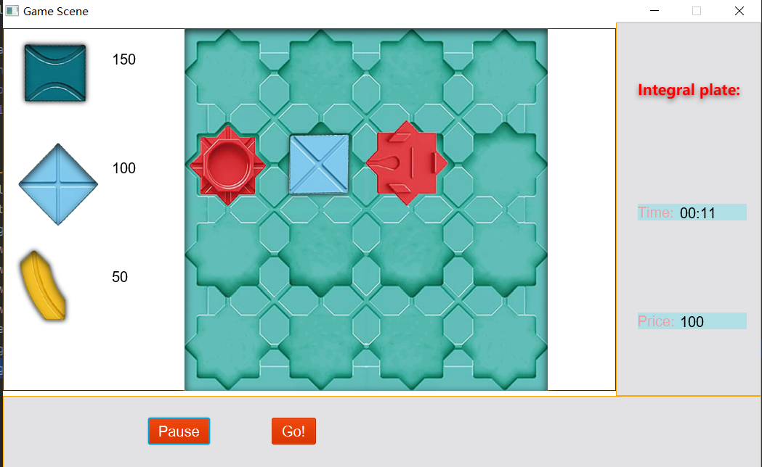

This is a false demonstration, the player's puzzle is not connected to the exit and entrance, the car will not reach the end and jump the game fails.

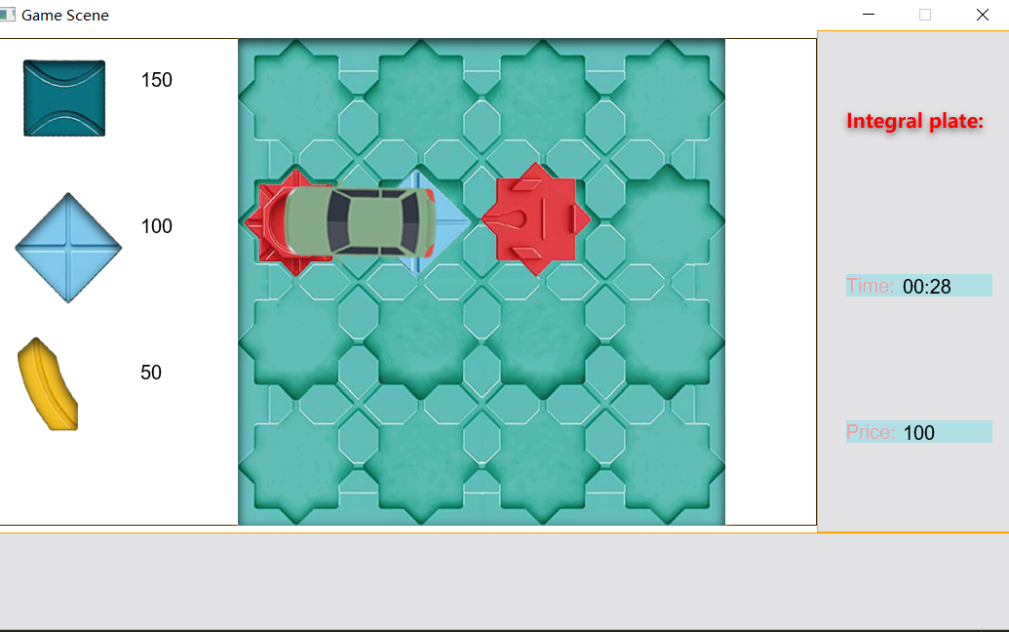

This is a correct case, when the go button is clicked the car will be generated at the start and run along the path, running to the end game wins.

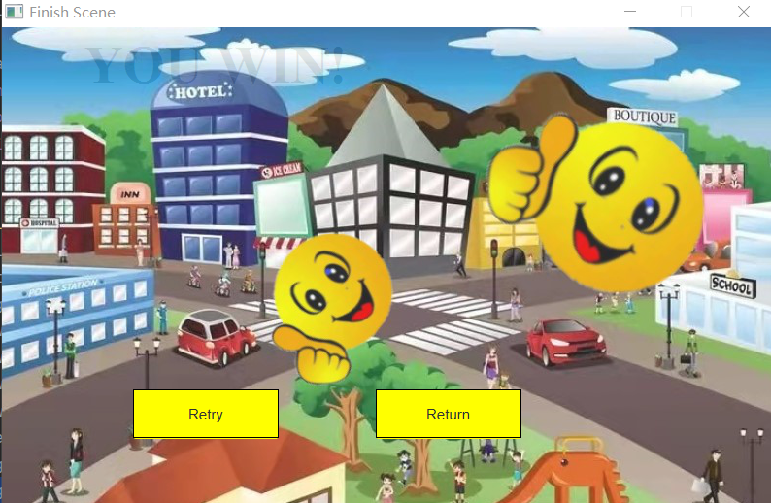

When the game is successful jump page, here you can choose to retry this level and return to the home page to select the level.

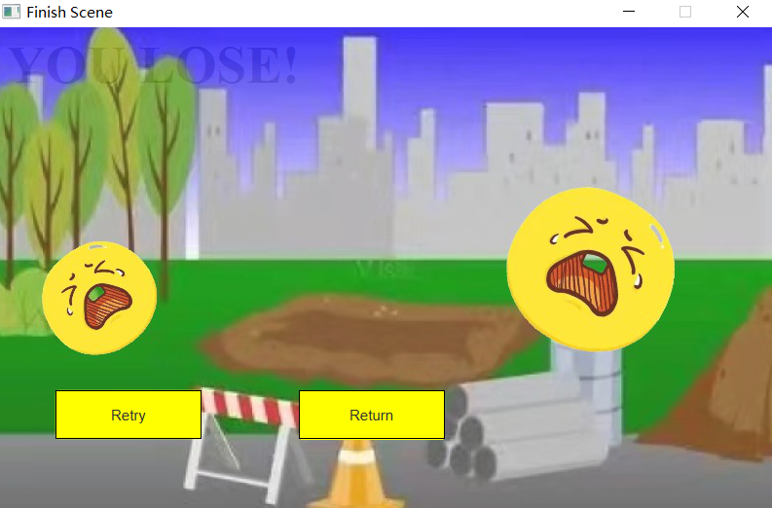

This is the screen where the game fails. You can also choose to retry the level and return to the home page to select the level.

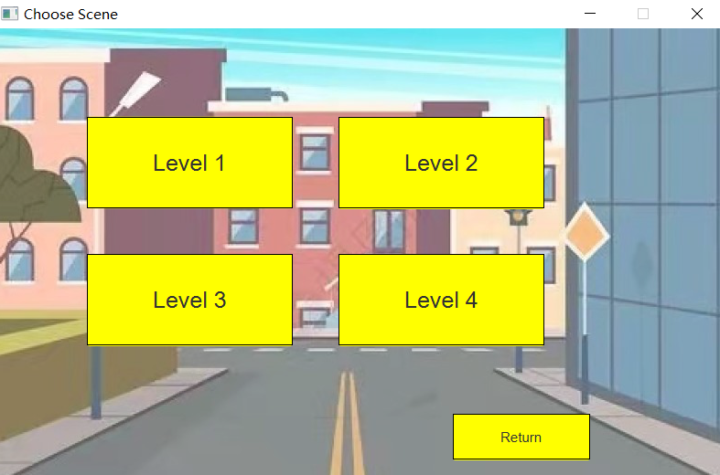

This is the level selection page, with four levels to choose from.

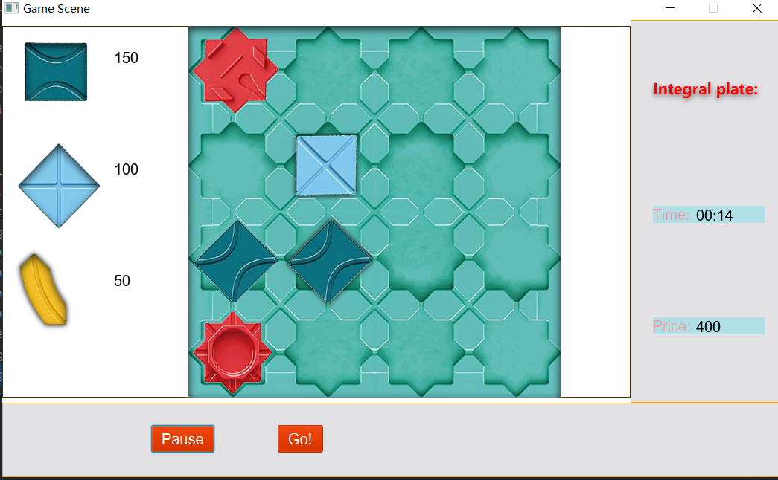

This is another difficulty level where more puzzle pieces are needed to get the car to the finish line. Of course, even if the following puzzle pieces are in the right order, the car will not get to the finish line because the first puzzle piece does not fit and the path will not be drawn.

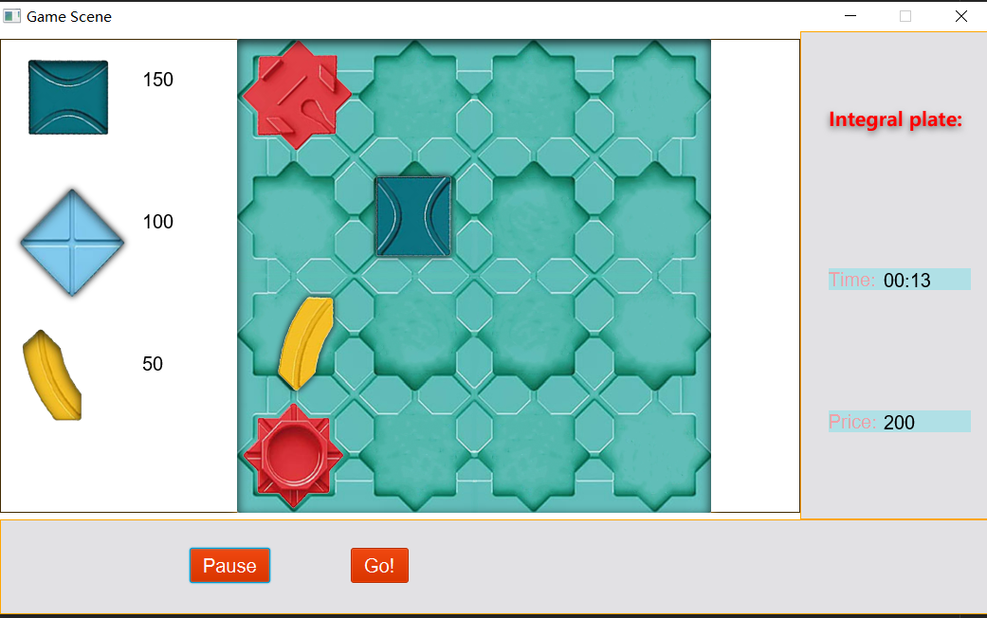

This is a correct example, the price of the puzzle used will be recorded in the right panel, including the time of play will also be recorded.

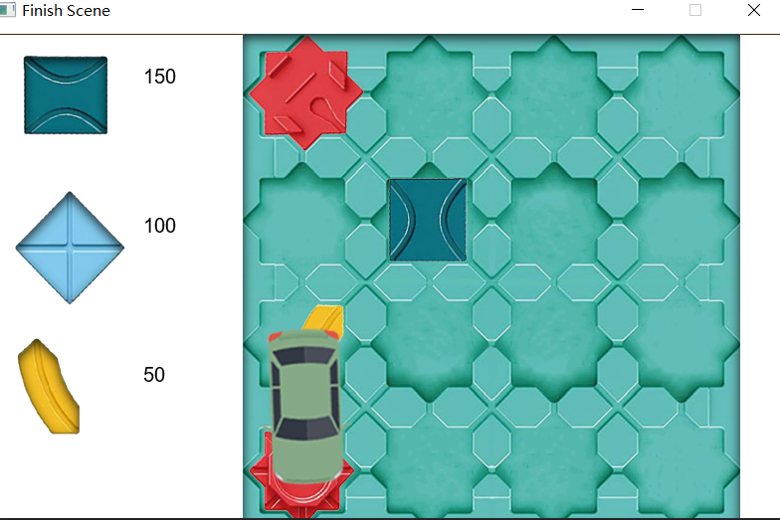

After correctly connecting the starting point and ending point, the car will follow the path to the end point. The choice of path is varied, depending on the player's choice, but this will not affect the path generation, because it is real-time, depending on how the puzzle pieces are placed.